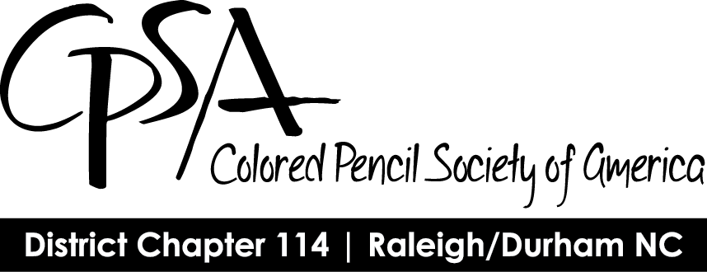

CPSA District Chapter 114
Membership Form
We are now accepting dues for the Nov. 1, 2022–Oct. 31, 2023 membership year.
Date: Click or tap here to enter text.

Membership is open to individuals 18 years of age or older. Annual dues for District Chapter 114 are $20.

You must be a current member of CPSA National to be affiliated with a local chapter. To join CPSA National go to www.CPSA.org, Membership, How to Join or Renew. Annual dues for CPSA National are $45.

Membership Options:

☐ | I am a new, first-time member and I am a member of the CPSA National organization for 2022 - 2023
☐ | I am renewing from last year and I have renewed my membership in the CPSA National organization for 2022 - 2023
☐ | I am rejoining after a lapse in membership and I have rejoined CPSA National for 2022 - 2023

Member Information:

Name | Click or tap here to enter text.
Address | Click or tap here to enter text.
Phone | Click or tap here to enter text.
Email | Click or tap here to enter text.

Make check payable to CPSA District Chapter 114. Mail completed form and payment to:

Theresa Baumgartner
5837 Laurel Rock Lane
Raleigh, NC 27613

